Student Name: Tejas Pramod Bhat UID: 24BAI70851
Branch: AIT-CSE (AIML) Section/Group: 24AIT_KRG-1A
Semester: 5
Subject Name: Database Management System Subject Code: 24CSH-298

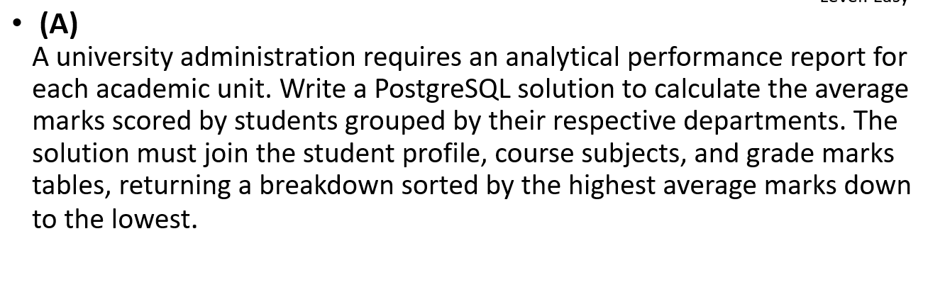

SOFTWARE REQUIREMENTS:
Database Management System:
Oracle Database Express Edition (Oracle XE)
PostgreSQL Database
Database Administration Tool / Client Tool:
Oracle SQL Developer (for Oracle XE)
pgAdmin (for PostgreSQL)

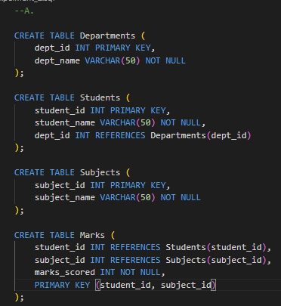
CODE SCREENSHOTS:

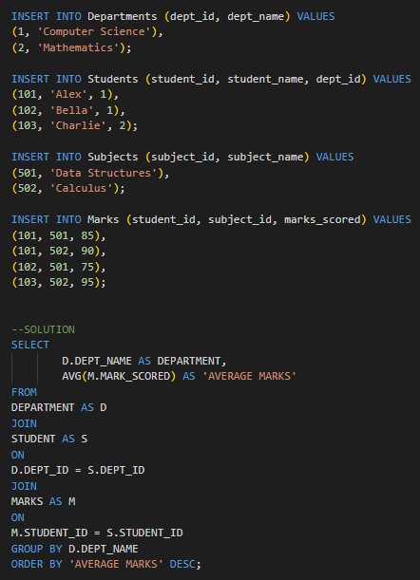

OUTPUT SCREENSHOTS:
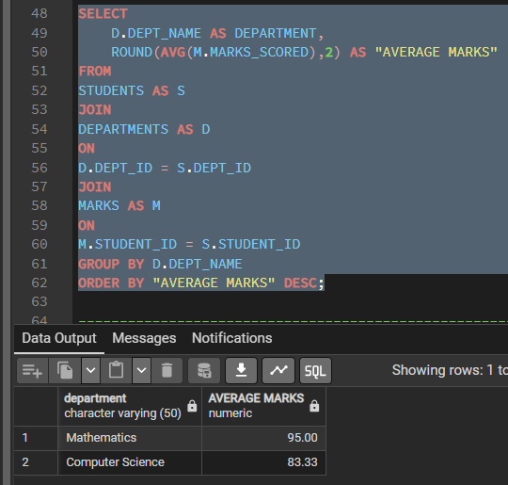

LEARNING OUTCOMES:
After completing this experiment, I was able to:
- Understand how to use JOIN to combine data from multiple tables.
- Learn how to use the AVG() aggregate function to calculate average marks.
- Apply GROUP BY to organize data department-wise.
- Use ORDER BY to sort the results from highest to lowest average marks.
- Generate a meaningful analytical report by integrating student, department, subject, and marks data.

CONCLUSION:
The PostgreSQL query successfully generated a department-wise performance report by joining the relevant tables, calculating the average marks using the AVG() function, grouping the data by department, and sorting the results in descending order. This experiment demonstrated the effective use of SQL joins, aggregate functions, grouping, and sorting to perform data analysis and produce useful academic performance reports.

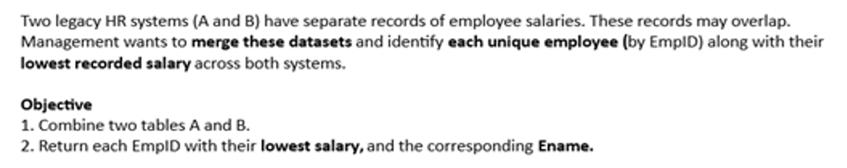

SOFTWARE REQUIREMENTS:
Database Management System:
Oracle Database Express Edition (Oracle XE)
PostgreSQL Database
Database Administration Tool / Client Tool:
Oracle SQL Developer (for Oracle XE)
pgAdmin (for PostgreSQL)

CODE SCREENSHOTS:
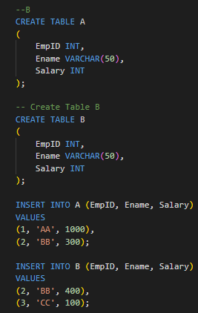

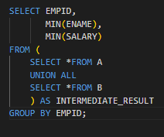

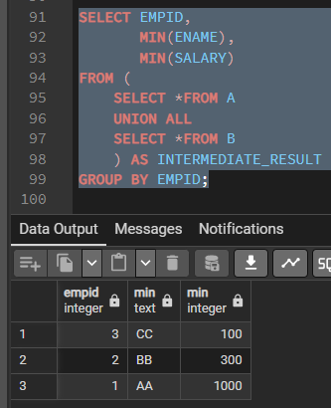
OUTPUT SCREENSHOTS:

LEARNING OUTCOMES:
After completing this experiment, I was able to:
- Understand how to use JOIN to combine data from multiple tables.
- Learn how to use the AVG() aggregate function to calculate average marks.
- Apply GROUP BY to organize data department-wise.
- Use ORDER BY to sort the results from highest to lowest average marks.

- Generate a meaningful analytical report by integrating student, department, subject, and marks data.

CONCLUSION:
The PostgreSQL query successfully generated a department-wise performance report by joining the relevant tables, calculating the average marks using the AVG() function, grouping the data by department, and sorting the results in descending order. This experiment demonstrated the effective use of SQL joins, aggregate functions, grouping, and sorting to perform data analysis and produce useful academic performance reports.

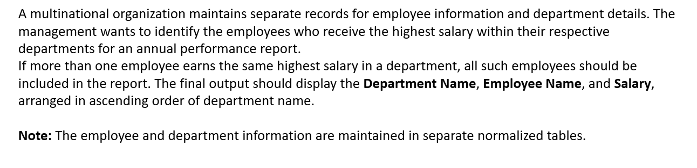

SOFTWARE REQUIREMENTS:
Database Management System:
Oracle Database Express Edition (Oracle XE)
PostgreSQL Database
Database Administration Tool / Client Tool:
Oracle SQL Developer (for Oracle XE)
pgAdmin (for PostgreSQL)

CODE SCREENSHOTS:
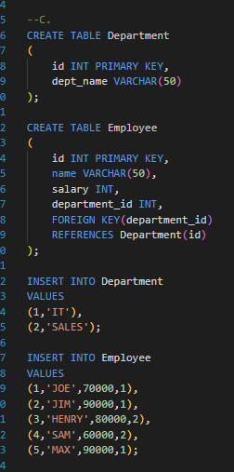

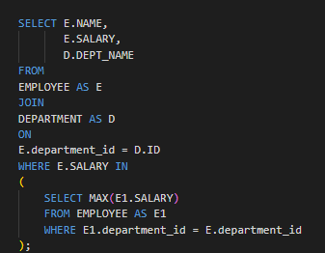

OUTPUT SCREENSHOTS:
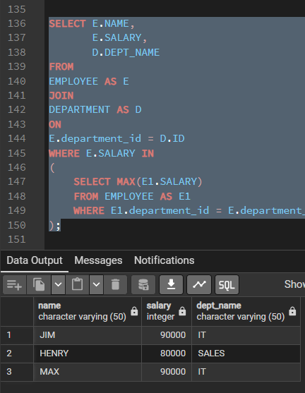

LEARNING OUTCOMES:
After completing this experiment, I was able to:
- Understand how to retrieve data from multiple normalized tables using JOIN operations.
- Learn to identify employees with the highest salary within each department using SQL queries.
- Apply aggregate functions such as MAX() to determine the maximum salary in each department.
- Use subqueries or equivalent SQL techniques to compare employee salaries with the highest departmental salary.
- Handle situations where multiple employees share the highest salary, ensuring all qualifying employees are included in the result.

CONCLUSION:
The SQL query successfully identified the employee(s) with the highest salary in each department by joining the employee and department tables and using the MAX() aggregate function with a subquery. It correctly included all employees who shared the highest salary within their respective departments and displayed the department name, employee name, and salary in ascending order of department name. This experiment demonstrated the effective use of SQL joins, aggregate functions, subqueries, and sorting techniques to generate meaningful organizational reports.

